**Development Automation Script Analysis**

**Overview**

The provided script is a comprehensive end-to-end automation tool for software development that transforms technical specifications into production-ready code with integrated components. The script operates in two major phases:

1. **Code Generation Phase**: This phase reads technical specifications from an Excel file, analyzes each specification, and generates individual Python modules based on these specifications using Azure OpenAI. Each module includes complete implementation, error handling, documentation, and unit tests.
2. **Integration Phase**: This phase examines the relationships between the generated modules, analyzing function calls, class instantiations, and dependencies. It then creates an integrated solution that properly orchestrates these components, with comprehensive documentation of the relationships.

The tool leverages Azure OpenAI API for both intelligent code generation and relationship-aware integration, ensuring that the final output is not just a collection of individual modules but a cohesive, well-documented solution.

**Input/Output**

**Input**

* **Excel File**: Contains technical specifications and user stories with the following structure:
  + User story column (containing user story ID information)
  + Technical specification column (containing detailed requirements)
* **Environment Variables for Azure OpenAI**:
  + AZURE_OPENAI_API_KEY: Authentication key
  + AZURE_OPENAI_ENDPOINT: API endpoint URL
  + AZURE_OPENAI_API_VERSION: API version to use
  + AZURE_OPENAI_CHAT_DEPLOYMENT_NAME: Name of the model deployment

**Output**

* **Code Generation Directory** (code_generation_YYYYMMDD_HHMMSS/):
  + Subdirectory for each user story (e.g., US_141/)
    - Multiple attempt directories showing the progression of code generation:
      * attempt_initial/: Initial code generation
      * attempt_validated_fail/: Failed validation (if applicable)
      * attempt_correction/: Code after corrections
      * attempt_final_corrected/ or attempt_final_validated/: Final version
    - Validation results JSON file
* **Integrated Solution Directory** (integrated_solution_YYYYMMDD_HHMMSS/):
  + Individual module files named with user story IDs (e.g., US_141_code.py)
  + Main integration file (integrated_solution.py)
  + Enhanced __init__.py with imports and relationship documentation
  + Comprehensive documentation:
    - README.md: Architecture overview and key components
    - RELATIONSHIPS.md: Detailed documentation of component relationships
    - enhanced_api_documentation.json: Machine-readable API documentation
  + Module dependency visualization (module_dependencies.png)
  + setup.py for package installation

**Process Flow Design**

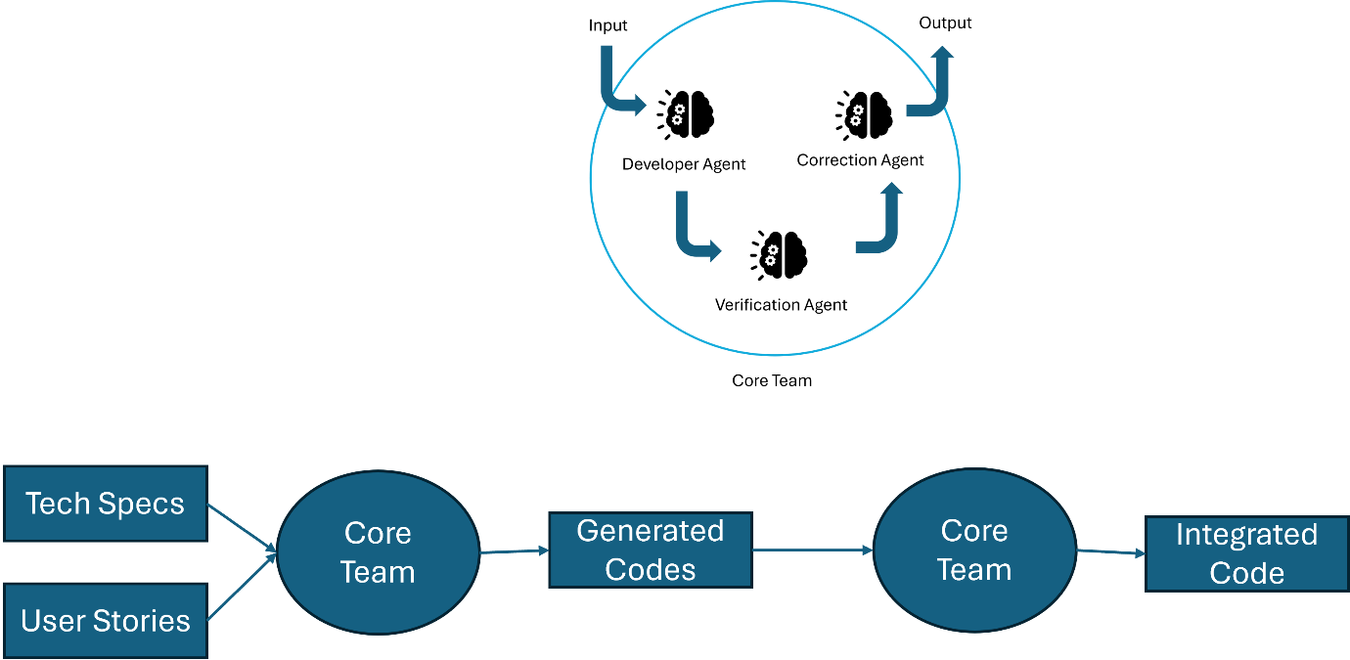

**Detailed Execution Flow**

1. **Configuration and Initialization**
   * combined_code_generation_and_integration() serves as the main entry point
   * check_openai_config() verifies Azure OpenAI credentials
   * Configure logging with detailed format for debugging
2. **Code Generation Phase**
   * process_tech_specs(excel_file_path):
     + Reads technical specifications from Excel using read_tech_specs_from_excel()
     + Creates timestamp-based output directory
     + Initializes AI model for code generation
     + For each specification:
       - Extract user story ID using regex pattern matching
       - Create user story-specific directory
       - Initialize CodeGenerator with developer, validator, and corrector prompts
       - Set up a state graph for the generation-validation-correction workflow
       - Execute the graph with the technical specification as input
       - Log progress and save code at each stage
3. **Code Generation State Graph**
   * developer(): Generates initial code
     + Formats developer prompt with technical specification
     + Invokes AI model to generate code
     + Extracts pure code from the response
     + Saves code to attempt_initial folder
   * validator(): Validates generated code
     + Formats validator prompt with specification and code
     + Invokes AI model to validate the code
     + Analyzes response to determine if validation passed
     + Saves results to JSON file
     + Saves code to attempt_validated_pass or attempt_validated_fail folder
   * correction() (If validation fails): Corrects code issues
     + Formats corrector prompt with specification, code, and validation feedback
     + Invokes AI model to generate corrected code
     + Saves corrected code to attempt_correction folder
     + Final code saved to attempt_final_corrected folder
4. **Integration Phase**
   * integrate_code_with_enhanced_relationships(code_generation_dir):
     + Creates timestamp-based output directory for integrated solution
     + Finds all code files using find_code_files() with priority order
     + Reads code content using read_code_files()
     + Saves individual modules with proper names
5. **Enhanced API Documentation Generation**
   * EnhancedAPIDocGenerator.generate_all_module_docs(code_contents):
     + For each module:
       - Parse AST using RelationshipVisitor
       - Extract docstrings, functions, classes, methods
       - Extract relationships:
         * Which functions call other functions
         * Which functions instantiate classes
         * Which attributes are accessed
         * Inheritance relationships
       - Apply post_process() to build bidirectional relationships
       - Save as structured JSON
6. **Relationship Documentation and Visualization**
   * create_relationship_documentation() creates detailed markdown
   * try_generate_dependency_graph() creates visual representation
   * Save enhanced API documentation as JSON
7. **Integrated Code Generation**
   * EnhancedCodeIntegrator.generate_integrated_code(module_docs):
     + Format API docs for LLM prompt
     + Create integration prompt focusing on relationships
     + Generate integrated code using AI
     + Validate proper module references
     + Fix any issues with imports or references
     + Add header documentation
8. **Supporting Documentation and Files**
   * Generate enhanced __init__.py with imports and relationship info
   * Create detailed README.md explaining architecture and components
   * Create setup.py for package installation

**Input Fields Description**

|  |  |  |  |
| --- | --- | --- | --- |
| **Field Name** | **Description** | **Input Type** | **Validation** |
| excel_file_path | Path to Excel file containing technical specifications | String | File must exist and be a valid Excel file format |
| code_generation_folder | Path to folder containing generated code (optional) | String | Directory must exist if specified |
| AZURE_OPENAI_API_KEY | API key for Azure OpenAI service | String | Must be non-empty |
| AZURE_OPENAI_ENDPOINT | Endpoint URL for Azure OpenAI service | String | Must be a valid URL |
| AZURE_OPENAI_API_VERSION | API version for Azure OpenAI service | String | Must be a valid version string format |
| AZURE_OPENAI_CHAT_DEPLOYMENT_NAME | Deployment name for Azure OpenAI chat model | String | Must be a valid deployment name |
| user_story_id | ID of the user story being processed | String | Extracted using regex pattern matching |
| technical_specification | Detailed requirements for a module | String | Must contain sufficient information for code generation |

**Issues/Error Handling**

|  |  |  |
| --- | --- | --- |
| **Sr No** | **Issue/Error** | **Solution** |
| 1 | Missing Azure OpenAI configuration | Script attempts to set default values first; if still missing, raises detailed EnvironmentError with list of missing variables |
| 2 | Excel file not found or invalid format | Catches exception, logs detailed error message with file path and error type |
| 3 | User story ID not found in text | Falls back to generating ID from content hash if regex patterns fail |
| 4 | Code validation failures | Automatically attempts correction with specific validation feedback; logs details of issues |
| 5 | Syntax errors in generated code | Two-level fallback: first tries AST parsing, if fails falls back to AI-based extraction of documentation |
| 6 | Missing libraries for visualization | Graceful degradation - catches ImportError separately from other exceptions, skips visualization but continues integration |
| 7 | Module reference issues in integrated code | Pattern matching with regex to detect and fix improper module references |
| 8 | AI model rate limiting or throttling | Retry mechanism built into OpenAI client with increasing backoff |
| 9 | JSON extraction failures from AI responses | Multiple pattern matching attempts with fallback to text-based detection |
| 10 | Code generation failures for specific specifications | Logs error and continues with other specifications instead of failing entire process |

The script uses a comprehensive logging system throughout, with INFO, WARNING, and ERROR levels appropriately used to provide visibility into the process. It also implements graceful degradation, where failures in non-critical components don't stop the overall process, ensuring maximum resilience.